The World, Residences at Sea – A One-of-a-Kind Ship

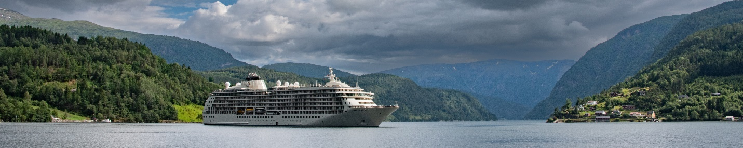

FORT LAUDERDALE, FLORIDA – The World is the largest private residential yacht on earth where its Residents travel the globe without ever leaving home. This community at sea remains the only private residential mega yacht in operation today having visited over 1,000 ports of call in more than 120 countries. With a continuous worldwide itinerary that enables the vessel to span the globe every two-to-three years, the Ship is a complete floating city, equipped with high-end facilities and luxurious amenities that create an intimate, refined atmosphere for its Resident owners. The strikingly beautiful and well-appointed Ship promises personalized, anticipatory service customized to its Resident’s preferences in a warm and inviting ambience much like that of a private yacht, well-staffed private home, or exclusive country club. The World is a unique combination of six-star hotel with luxury services and amenities and private mega yacht.

The Lifestyle

A lifestyle aboard The World offers opportunities to travel and explore to the planet’s most exotic and well-known destinations as well as to lesser known and more remote locales with other adventure seekers, all from the comfort of your own private Residence. Spend the day exploring and return to the comforts of home. You’ll sleep in your own bed surrounded by family photos, your own cherished artwork and furniture, and other personal possessions. No packing or unpacking needed, not to mention you’ll be pampered from sunup to sundown by knowledgeable and experienced staff who know your personal preferences. Every few days you’ll walk out your front door to a new and exciting part of the world. It’s the ultimate adventure in total luxury.

The Community

This exclusive community enjoys the ultimate combination of luxury travel with world-class dining, custom destination experiences, onboard programming, expeditions, overland journeys, and enriching cultural events – all designed to ‘bring the destination alive’. Esteemed lecturers, Nobel Laureates, and honored speakers quench Residents’ thirst for learning on myriad topics. This unique lifestyle fosters a warm and welcoming atmosphere, a sense of community, and the creation of lasting friendships. Residents form strong bonds with one another, often based on similar interests like diving, photography, food and wine, books, golf, fitness and more.

Web site www.aboardtheworld.com

CEO Tom Wolber

Management Company ROW Management Ltd., Fort Lauderdale, Florida, is responsible for sales, marketing, operations, and administration of The World.

Flag Bahamas

Principal Dimensions Tonnage: 43,188 gross tons Length: 644.2 ft. (196.35 m)
Beam: 97.8 ft. (29.8 m) Draft: 22 ft. (7.05 m)
Decks: 12 Maximum speed: 18.5 knots

Ownership Privately owned by Residents of The World – approximately 150 families from 20 countries around the world.

Occupancy Average occupancy is 150 - 200 Residents & Guests which provides an intimate atmosphere.

Average Stay Residents travel for as long as they desire, spending an average of three to four months (combined) on board every year.

Crew An international complement of long-standing crew, including approximately 300 experienced staff from 42 countries.

The Journey

The World’s Captains and Residents collectively determine the Ship’s yearly itinerary based on the best sea routes and Residents’ personal interests. Itineraries are determined three years in advance by a community-wide vote. Continuous worldwide journeys, with a focus on extended stays of an average three days in port, ensure that Residents have sufficient time to explore their favorite destinations. Unlike most vessels, The World spends nearly twice as many days in port as at sea. Every few days Residents wake up to look outside their window at a new and exciting port of call.

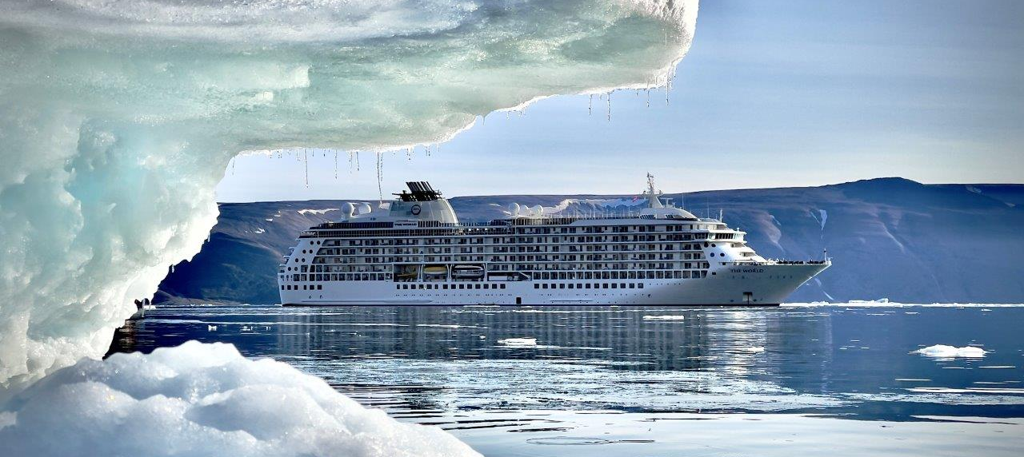

The Beginning

The vision behind The World was to create a way in which travelers never had to disembark. They could sail for as long as they wished from the comfort of their own private Residence. As such, in 1997 a team of experienced professionals gathered and began working on the first ever vessel where people could travel the globe without leaving home. Construction of the vessel began in May 2000 in Rissa, Norway and in March 2002 the vision was realized when The World set sail from Oslo with its inaugural Residents and Crew on board. Her maiden voyage departed from Lisbon, Portugal on 2 May 2002 and on 17 May 2002 she was christened in Venice, Italy. On 30 September 2003, the Residents purchased the Ship, and in June 2006, the original inventory of Residences was sold out.

Ship Designers

Petter Yran and Bjørn Storbraaten designed The World. This Oslo-based team successfully combined nautical elements with clean, contemporary lines, imparting the aura of a private yacht to this magnificent 12-deck Ship, while enhancing an intimacy with the sea that is not available on land.
Environmental Interests

The World is the first Ship of its size designed to burn marine diesel oil rather than heavy bunker fuel, making for a much more environmentally friendly Ship. The World now burns only low sulfur marine gas oil which meets the strictest international and local regulations thus allowing the vessel to call in areas where ships burning heavy fuel are banned. The World was also the first Ship to feature the unique Scanship wastewater cleaning system in which wastes are filtered by means of a flotation system. It was supplemented in 2016 with a Wartsila membrane bioreactor treatment system to meet the present wastewater discharge standards. The team on board is constantly identifying new and innovative elements to improve the Ship’s environmental footprint such as:

- An initiative to reduce single-use plastics includes providing water bottle refill stations and replacing single-use plastics with biodegradable products, i.e., food containers, cutlery, cups, etc.
- A reduction in the Ship’s carbon footprint is achieved by purchasing locally as much as possible as well as increased procurement of organic products such as food items and bath amenities.
- Implementing LED (light-emitting diode) technology throughout the Ship and replacing existing high wattage halogen and incandescent lamps with the latest and more efficient LED lighting technology to reduce energy consumption.
- A dedicated Environmental Engineer is responsible for the prevention of environmental incidents and overall adherence to the Ship’s Environmental Management System including training of all crew members. A Health, Safety, and Environmental Officer focuses on working standards as well as the growing environmental regulations.

Private Residence Details

There are 165 Residences aboard The World ranging from studios to expansive three-bedroom apartments. All homes have been sold although there are a select number of Residences available for resale. Annual ownership costs are additional and are based on square footage of the apartments. The spacious Residences include 106 two- and three-bedroom apartments, 19 one- and two-bedroom studio apartments, and 40 studios. Interiors are customized based on Residents’ individual tastes and feature everything from contemporary to transitional to traditional decor.

Prices range from $2 to $15 million plus annual ownership costs for studios to three-bedroom homes.
Residences range in size from 330 sq ft (approx. 30 sq m) to largest three bedroom home 3,242 sq ft (301 sq m).

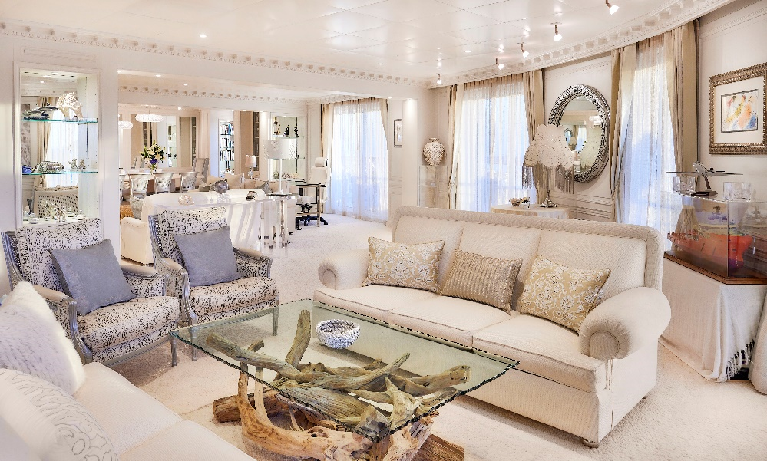

The World Spa & Wellness Center

The World Spa & Wellness Center is a complete retreat for the mind, body and soul offering one of the most comprehensive spa and wellness programs at sea and designed to support Residents’ commitment to healthy living and an active lifestyle. A team of skilled therapists craft the perfect combination of services and relaxing treatments in support of Residents’ pursuit of wellness, fitness, and beauty. Products used are made with the highest quality, handpicked ingredients, as well as the latest hair, body and skincare techniques to keep those who indulge looking and feeling great. Residents are pampered with a complete menu of services including body, massage, and facial treatments; advanced skincare; hand, nail and foot treatments; haircare services and grooming. A physiotherapy program comprises both hands-on treatment and therapeutic rehabilitation, including rehabilitative Pilates. Highly experienced physiotherapists work in conjunction with the Ship’s onboard doctor and fitness specialists.

Dining and Lounges

Renowned for its delicious and inventive cuisine and award-winning wine and sake program, The World’s Food & Beverage Team works with chefs and winemakers to offer Residents unique and memorable epicurean experiences.

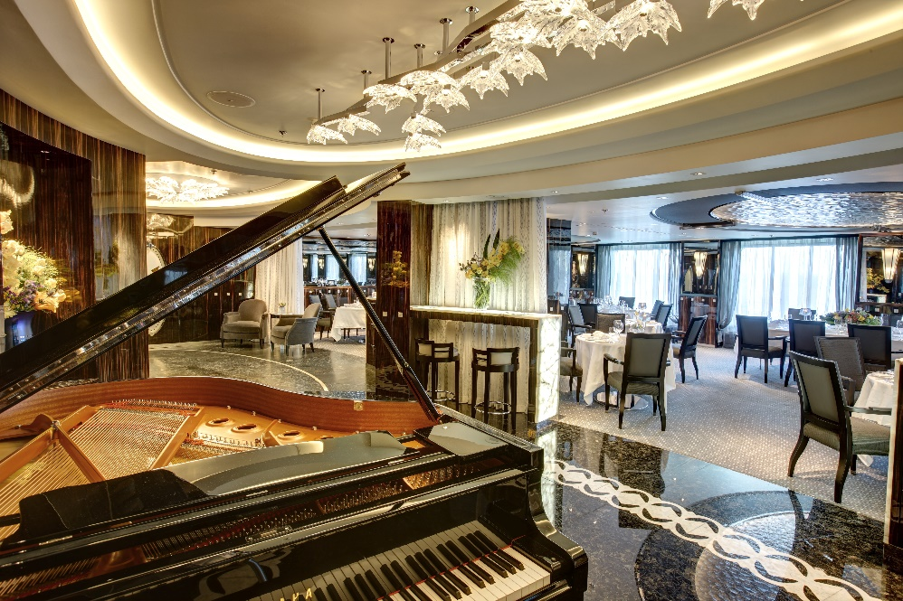

Extraordinary skill and culinary mastery delight diners’ palettes with international creations often using locally sourced produce and specialty ingredients to enhance the cultural experience. Restaurants offer light options and cater to special requests including kosher, vegetarian, and diabetic diets. There are four major restaurants are on board:

- East – contemporary Pan-Asian-inspired décor creates an elegant setting to enjoy traditional and innovative cuisine from China, Thailand, India, and Japan including superior sushi and sashimi to delight even the most discerning palates. Locally sourced and hand-selected items from local markets. Offering indoor and outdoor dining.
- Marina – enjoy the finest steaks and freshest seafood with a Chef’s Table that showcases the preparation of fresh oysters, seafood, freshly carved Ibérico ham and regional delights from the land and sea. Features relaxed indoor and outdoor dining, over-the-water seating on an open marina platform and unrivaled wine selections from a custom-made wine vault.
- Portraits – a best-of-the-best dining experience featuring masterfully prepared haute cuisine, Michelin-star level fine dining, and regional menus with the highest quality, locally sourced products. A truly gastronomic experience in an elegant and intimate setting surrounded by sophisticated Art Deco-inspired interior design and jewel-embellished artwork. Guest chefs from around the world prepare special, multi-course menus with wine pairings. Features a custom-made wine vault.
- Tides – Mediterranean style cuisine with a northern Italian flair that includes homemade pasta. Menus are designed to help Residents & Guests with their health and wellness goals. Features indoor and outdoor dining, a custom wine vault and spectacular ocean views.

Other dining options include:

- Fredy’s Deli Barista – specialty and destination-inspired coffees, to-go items, fresh pastries, light fare, and salads.
- Fredy’s Deli Café – full-service dining or express counter orders with sandwiches, salads, and pastries.
- Fredy’s Deli Lounge – for coffee and additional express dining seating.
- Fredy’s Deli Marketplace – authentic gourmet delicatessen offering fresh local produce, wine, champagne, spirits, and retail products. A wide variety of food and beverage items, often including fresh local produce, is available for Residents who love to cook in their Residences.
- Culinary Corner – open on Sea Days and expeditions; features pre-prepared foods (soup, sandwiches).
- Poolside Grill – poolside venue offering casual cuisine such as burgers, salads, and light meals.

Special services:

- Bali beds – located outside on Deck 12 aft, Residents can relax and enjoy the view with a cocktail, meal or snack while sailing or in port. Spend the night under the stars to the hum of ocean waves in your own private bed made up especially to your liking by the Housekeeping Team.
- Call-a-Chef™ – a unique dining option offering private, In-Residence chef service – a wonderful opportunity to celebrate a special occasion with a personalized dinner party.
- In-Residence Dining is also available.

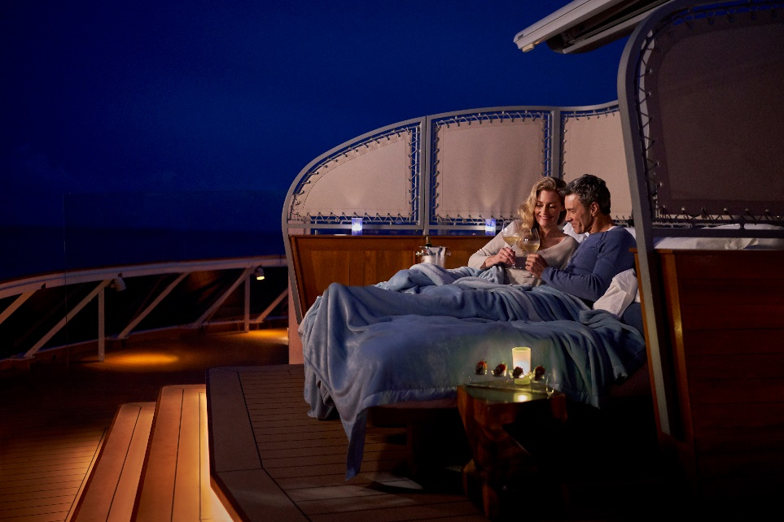

Residents can order online or call for delivery. Food and beverage items can also be ordered and stocked in the Resident’s apartment in advance of their return to the Ship.

A variety of cocktail lounges and bars feature selections from The World’s award-winning wine and sake program.

- Cigar Club – traditional English-style smoking and cognac bar to enjoy authentic, hand-rolled Cuban tobacco with a large humidor and cognac cabinet. Also offering vintage ports, calvados, Madeira’s, scotches, sherries, and wines.
- Cove – secluded lounge featuring cocktails, a private, world-class poker room and blackjack table.
- Lobby Bar – classic bar serving wine and champagne, signature cocktails, and an extensive selection of high-end spirits.
- Marina Bar – full-service bar with breathtaking views offering an extensive selection of wines, spirits and The World’s signature and classic cocktails.
- Pool Bar – tropical cocktails, fresh juices and smoothies prepared with organic super foods.
- Quantum Bar – casual sports bar offering an extensive selection of high-end spirits, champagnes, craft beers, draft beers, and The World’s signature and classic cocktails.
- Regatta Bar – home of The World Yacht Club offering refreshing drinks, and spectacular views.
- The Garden – relax in the tearoom and lounge with a perfectly brewed cup.

Onboard Facilities, Services and Amenities

The Ship offers myriad services and amenities. A few of note include an art gallery, an award-winning wine list, Bali beds, biking, billiards, Call-a-Chef, Fitness Center offering group classes and personal training, children’s play area and hobby room with arts and crafts, conference center, diving, DVD collection, florist, game room, gourmet deli, hiking, housekeeping, In-Residence dining, kayaking, laundry/dry cleaning, library, Medical Center, nightclub, non-denominational chapel, physical therapist, telepsychiatry, pools, restaurants and cafes, snorkeling, sports center offering real and virtual golf excursions to the world’s top-ranked courses, tennis court, The World Boutique & Showroom, The World Concierge, The World Spa & Wellness Center, theater, video and board games, video-on-demand TV and movies, a youth program (Camp Caravel) and more.

Guest Stay Program

A Guest Stay Program allows interested and qualified potential Residents to experience firsthand the unique and luxurious lifestyle aboard The World prior to a purchase decision. Guest Stay access is quite limited and is by invitation only due to the exclusive and private nature of The World.

About The World

Launched in 2002, The World® is the largest privately owned, residential yacht on earth with 165 luxury Residences. A diverse group of Residents from 20 countries own the homes onboard and share interests in world cultures, history and adventure, and exploring fascinating destinations. They circumnavigate the globe every two to three years following an extraordinary itinerary that they select. In-depth expeditions and one-of-a-kind experiences are complemented by world-class amenities and impeccable service. To learn more about this unique lifestyle call 954-538-8449 or visit www.aboardtheworld.com.

Image Library / Press Inquiries
Kindly direct all media and photography requests to The Dovetail Agency:

Jayne Alexander
Telephone: +44 (0)20 3709 7809
Email: jayne@dovetail-agency.co.uk

Joanna Merredew
Telephone: +44 (0)20 3709 7809
Email: joanna@dovetail-agency.co.uk

# # #

September 2023

